**Software Development Project On**

“E-Commerce Shopping System”

In Partial Fulfillment of

Bachelor of Computer Application **(BCA)**

**Monark University (2023-2024)**



**Developed by:**

Mansuri Faizan (129)

Patel Vishva (229)

(Third Year Bachelor of Computer Application)

**Internal Faculty Guide:**

Prof. Sahil Sabugar

Rudra Goswami College Of Computer Application,

Naroda - DahegamRd, Vahelal,

Ahmedabad – 382330.

**College Certificate**

**MONARK UNIVERSITY**

RUDRA GOSWAMI COLLEGE OF COMPUTER APPLICATION

[Oct-2023]

# 

This is to certify that this project entitled **“E-Commerce Shopping system”** is carried out by **Mansuri Faizan & Patel Vishva** Studying at Bachelor of Computer Application in 5th Semester (Rudra Goswami BCA College, Ahmedabad) for partial fulfillment Bachelor of Computer Application degree to be awarded by Monark University.

This project work has been carried out under faculty Guidance. The project is fit to the considered at for evolution for the degree Of Bachelor of Computer Application.

**Place:** Ahmedabad

**Guide Name: Principle Name:**

**Prof. Sahil Sabugar Prof. Vanita Dandhwani**

# ACKNOWLEDGEMENT

­­

With due sense of respect and gratitude, We would like to extend our heartiest thanks to all those people who provide us wonderful guidance, support and experience to work at

# E-Commerce Shopping System

We will fall short in our duties, if we forget those people, which not only carved this way for us, but where there, whenever called for Prof. Sahil Sabugar, faculty of Rudra Goswami College of Computer Application and internal project guide us. They created desire in us to pursue our goal and to attain new heights. We acknowledge the kind assistance and encouragement given by him by giving us valuable information and clarifying our doubts. Also the other faculty members and our faculties of our lab have been very kind to us in the competition of our project.

These formal thanks are only TOKEN that we present to these wonderful people to appreciate their support and guidance given by them.

# INDEX

|  |  |  |
| --- | --- | --- |
| No. | INDEX | PAGE NO. |
| 1 | COMPANY PROFILE | 06 |
| 2 | PROJECT PROFILE | 07 |
| 3 | PROJECT DEFINITION | 08 |
| 4 | EXISTING SYSTEM | 10 |
| 5 | PROPOSED SYSTEM | 11 |
| 6 | TOOLS AND TECHNOLOGY | 12 |
| 7 | MODULES | 14 |
| 8 | DATA FLOW DIAGRAM | 16 |
| 9 | ENTITY RELATIONSHIP DIAGRAM | 20 |
| 10 | DATA DICTIONARY/TABLE DESIGN | 22 |



**Profile**



**PROJECT PROFILE**

|  |  |
| --- | --- |
| Project Title | Shopping System |
| Project Category | E-Commerce Web Application |
| Frontend | HTML5, CSS3,TYPESCRIPT& ANGULAR |
| Backend | C# & .NET |
| Server | SQL |
| IDE | Visual Studio Code |
| Guide | Prof. Sahil Sabugar |
| Member | Mansuri Faizan ( 129 )  Patel Vishva ( 229 ) |
| Group No. | 60 |

**PROJECT DEFINITION**

* Our E-Commerce Shopping System is a method of buying goods and services online. Our system allows people to buy good services & digital products.
* Our E-Commerce System is a complete shopping facility system program which looks after all of your customers, orders, and other activities.
* Our E-Commerce Shopping System is Provide lots of functions.
* Such data entry of customer, keeping records of all the things about customer’s orders pending payments and other good services. This system structure is become very simple to understand because of Data Flow Diagram provided by us.
* The demo of using the software such as customer detail from, data base of system is also provided by us.



**System & Technology**

**EXISTING SYSTEM**

* The Existing System has several modules like registration, orders and product list etc.
* All these modules currently run manually and on basis of paper work.
* These Existing E-Commerce Shopping System is based on paper work. And the documentation of current system is traditional documentation and management.

**PROPOSED SYSTEM**

* Our E-Commerce Shopping System is Login Authentication, The user cannot access any page without login. Once user is logged in the Application they will not allow to login again till login is Expired.
* Our Application is single page Application. The page content and url changed without loading page. Our Application is user Friendly.

**TOOLS & TECHNOLOGY**

|  |  |
| --- | --- |
| TOOLS AND TECHNOLOGY | DISCRIPTION |
| HARDWARE | Intel Core i3 and above processor  8 GB RAM  512 GB HDD |
| SOFTWARE | Visual studio code, SQL server |
| FRONTEND | UI-DEVELOPMENT: HTML5, CSS3, ANGULAR, TYPESCRIPT, BOOTSTRAP. |
| BACKEND | C# & .NET CORE |
| SERVER | IIS |

**MODULES**

**Modules**

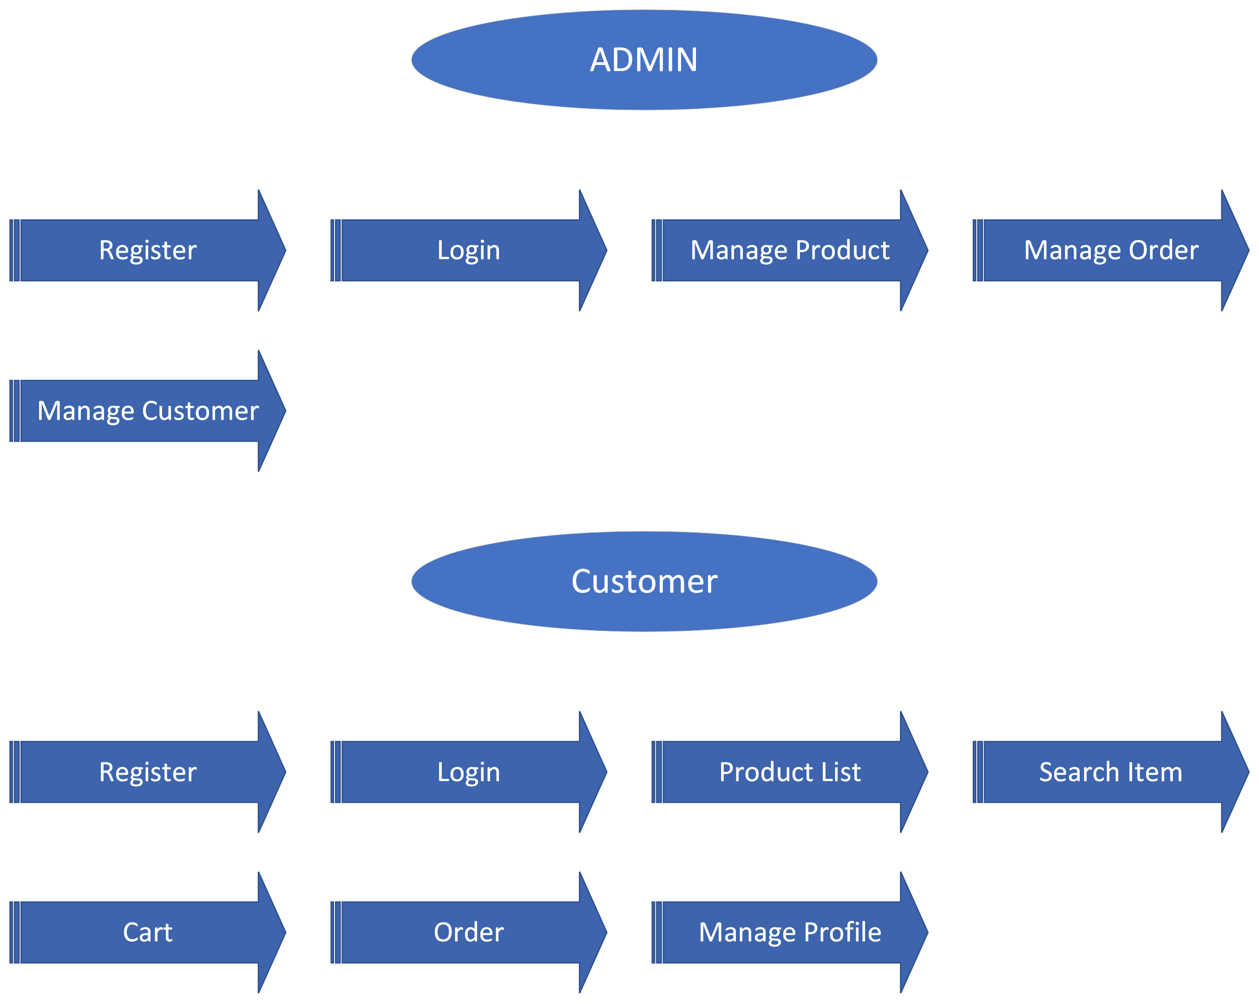



**DFD Diagram**

**DATAFLOW DIAGRAM**

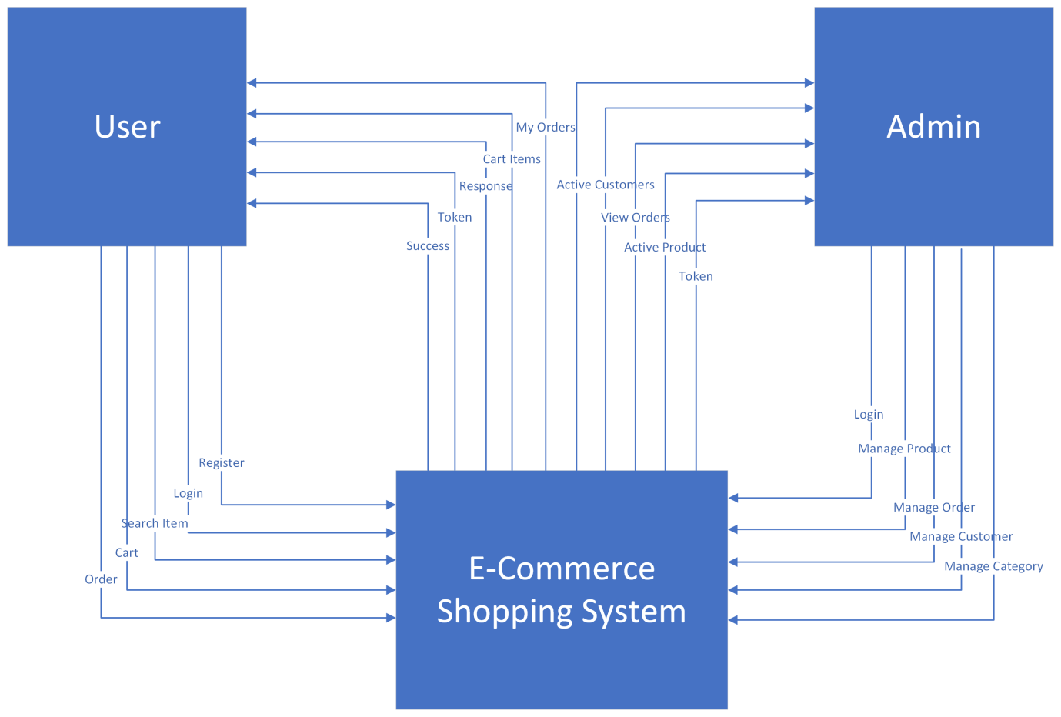

**LEVEL 1- ADMIN**

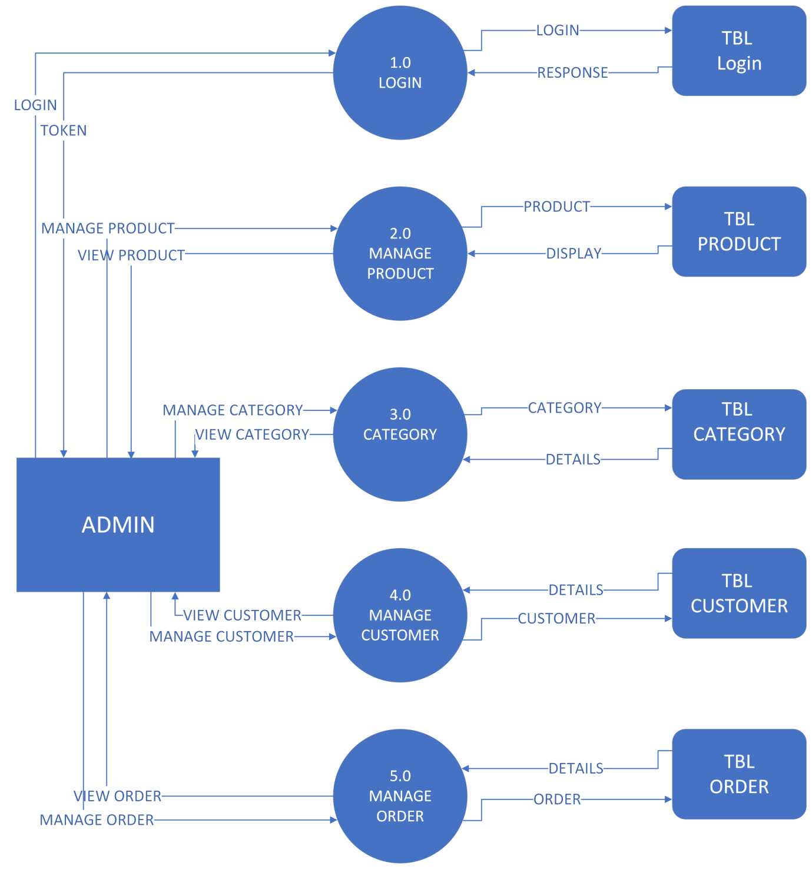

**LEVEL 2- CUSTOMER**

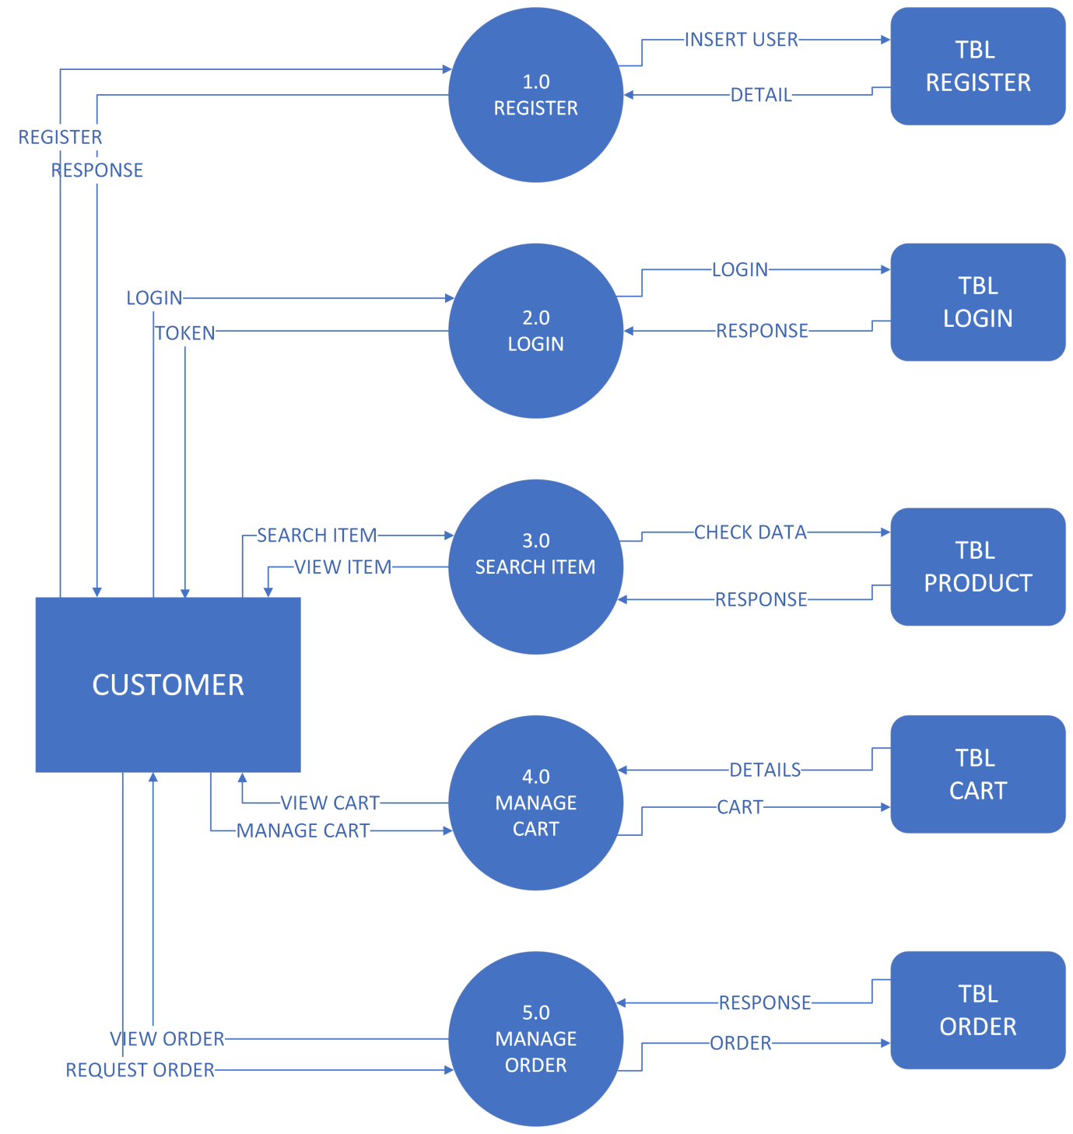

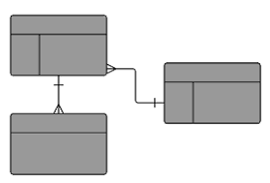**ENTITY RELATIONSHIP DIAGRAM**

**ERD Diagram**





**Table List**

**LIST OF TABLE**

|  |  |
| --- | --- |
| **NO.** | **TABLE NAME** |
| 1 | Customers |
| 2 | Products |
| 3 | Orders |
| 4 | Role |
| 5 | Cart |
| 6 | Categories |
| 7 | Brands |
| 8 | Users |
| 9 | Sales |
| 10 | ProductMapping |

**TABLE 1 Customers**

|  |  |  |  |  |  |
| --- | --- | --- | --- | --- | --- |
| NO | FIELD_NAME | DATATYPE | SIZE | CONSTRAINT | DESCRIPTION |
| 1 | Id | Int | - | Primary Key | Customer Id |
| 2 | FirstName | Varchar | 15 | not null | Customer FirstName |
| 3 | LastName | Varchar | 15 | not null | Customer LastName |
| 4 | Email | Varchar | 50 | not null | Custmoer Email |
| 5 | Password | Varchar | 10 | not null | Customer Password |
| 6 | Gender | Varchar | 10 | not null | Customer Gender |
| 7 | PhoneNumber | Varchar | 10 | not null | Customer Number |
| 8 | DateofBirth | Datetimeoffeset | - | not null | Customer DOF |
| 9 | Address | Varchar | 100 | not null | Customer Address |
| 10 | CreatedDateTime | Datetimeoffeset | - | not null | Created Date Time |
| 11 | CreatedBy | Int | - | not null | Created By |
| 12 | UpdatedDateTime | Datetimeoffeset | - | null | Updated Date Time |
| 13 | UpdatedBy | Int | - | null | Updated By |
| 14 | Active | Bit | - | not null | Is Customer Active ? |
| 15 | ActivationDate | Datetimeoffeset | - | not null | Cusdtomer Activated date |
| 16 | Activationkey | Varchar | 5 | not null | Customer Activation Key |

**TABLE 2 Products**

|  |  |  |  |  |  |
| --- | --- | --- | --- | --- | --- |
| NO | FIELD_NAME | DATATYPE | SIZE | CONSTRAINT | DESCRIPTION |
| 1 | Id | Int | 10 | Primary Key | Product Id |
| 2 | Img | Varbinary | max | not null | Product Img |
| 3 | Name | Varchar | 30 | not null | Product Name |
| 4 | CategoryId | Int | - | Foreign Key | Product Category |
| 5 | Description | Varchar | 100 | not null | Product Description |
| 6 | Price | Int | - | not null | Product Price |
| 7 | Discount | Int | - | not null | Product Discount |
| 8 | Quantity | Int | - | not null | Available |
| 9 | Color | Varchar | 15 | not null | Product Color |
| 10 | Measurment | Varchar | 15 | not null | Measurment Of Product |
| 11 | MeasurementValue | Varchar | 10 | not null | Measurement value |
| 12 | BrandId | Int | - | not null | Product Brand |
| 13 | CreatedDateTime | Datetimeoffeset | - | not null | Created Date Time |
| 14 | CreatedBy | Int | - | not null | Created By |
| 15 | UpdatedDateTime | Datetimeoffeset | - | null | Updated Date Time |
| 16 | UpdatedBy | Int | - | null | Updated By |

**TABLE 3 Orders**

|  |  |  |  |  |  |
| --- | --- | --- | --- | --- | --- |
| NO | FIELD_NAME | DATATYPE | SIZE | CONSTRAINT | DESCRIPTION |
| 1 | Id | Int | 10 | Primary Key | Order Id |
| 2 | CustomerId | Int | - | Foreign Key | Customerid |
| 3 | Quantity | Int | - | not null | Order Product Quantity |
| 4 | Amount | Int | - | not null | Order Amount |
| 5 | ProductId | Int | - | not null | Order Producr Id |
| 6 | PaymentMethod | Varchar | 20 | not null | Customer Payment Method |
| 7 | OrderDate | Datetimeoffeset | - | not null | Order Date |
| 8 | DeliveryAddress | Varchar | 100 | not null | Order Delivery Address |
| 9 | DeliveryDate | Datetimeoffeset | - | not null | Order Delivery Date |
| 10 | DeliveryCharge | Int | - | not null | Delivery Charge |
| 11 | Status | Varchar | 10 | not null | Delivery Status |
| 12 | CreatedDateTime | Datetimeoffeset | - | not null | Created Date Time |
| 13 | CreatedBy | Int | - | not null | Created By |
| 14 | UpdatedDateTime | Datetimeoffeset | - | null | Updated Date Time |
| 15 | UpdatedBy | Int | - | null | Updated By |

**TABLE 4 Role**

|  |  |  |  |  |  |
| --- | --- | --- | --- | --- | --- |
| NO | FIELD_NAME | DATATYPE | SIZE | CONSTRAINT | DESCRIPTION |
| 1 | Id | Int | 10 | Primary Key | Role Id |
| 2 | Name | Varchar | 20 | not null | Role Type |
| 3 | CreatedBy | Int | - | not null | Created By |
| 4 | UpdatedBy | Int | - | not null | Updated By |

**TABLE 5 Cart**

|  |  |  |  |  |  |
| --- | --- | --- | --- | --- | --- |
| NO | FIELD_NAME | DATATYPE | SIZE | CONSTRAINT | DESCRIPTION |
| 1 | Id | Int | 10 | Primary Key | Cart Id |
| 2 | CustomerId | Int | - | Foreign Key | Customer |
| 3 | ProductId | Int | - | Foreign Key | Product |
| 4 | Quantity | Int | - | not null | Cart Quantity |
| 5 | CreatedDateTime | Datetimeoffeset | - | not null | Created Date Time |
| 6 | CreatedBy | Int | - | not null | Created By |
| 7 | UpdatedDateTime | Datetimeoffeset | - | null | Updated Date Time |
| 8 | UpdatedBy | Int | - | null | Updated By |

**TABLE 6 ProductCategories**

|  |  |  |  |  |  |
| --- | --- | --- | --- | --- | --- |
| NO | FIELD_NAME | DATATYPE | SIZE | CONSTRAINT | DESCRIPTION |
| 1 | Id | Int | 10 | Primary Key | Cart Id |
| 2 | Name | Varchar | 20 | not null | Category Name |
| 3 | CreatedDateTime | Datetimeoffeset | - | not null | Created Date Time |
| 4 | CreatedBy | Int | - | not null | Created By |
| 5 | UpdatedDateTime | Datetimeoffeset | - | null | Updated Date Time |
| 6 | UpdatedBy | Int | - | null | Updated By |

**Table 7 Brands**

|  |  |  |  |  |  |
| --- | --- | --- | --- | --- | --- |
| NO | FIELD_NAME | DATATYPE | SIZE | CONSTRAINT | DESCRIPTION |
| 1 | Id | Int | 10 | Primary Key | Cart Id |
| 2 | Name | Varchar | 20 | not null | Category Name |
| 3 | CreatedDateTime | Datetimeoffeset | - | not null | Created Date Time |
| 4 | CreatedBy | Int | - | not null | Created By |
| 5 | UpdatedDateTime | Datetimeoffeset | - | null | Updated Date Time |
| 6 | UpdatedBy | Int | - | null | Updated By |

**TABLE 8 Users**

|  |  |  |  |  |  |
| --- | --- | --- | --- | --- | --- |
| NO | FIELD_NAME | DATATYPE | SIZE | CONSTRAINT | DESCRIPTION |
| 1 | Id | Int | 10 | Primary Key | Cart Id |
| 2 | FirstName | Varchar | 15 | not null | User Firstname |
| 3 | LastName | Varchar | 15 | not null | User Lastname |
| 4 | Email | Varchar | 50 | not null | User Email |
| 5 | Role Id | Int | - | Foreign Key | Users Role |
| 6 | Password | Varchar | 15 | not null | User Pasword |
| 3 | CreatedDateTime | Datetimeoffeset | - | not null | Created Date Time |
| 4 | CreatedBy | Int | - | not null | Created By |
| 5 | UpdatedDateTime | Datetimeoffeset | - | null | Updated Date Time |
| 6 | UpdatedBy | Int | - | null | Updated By |

**TABLE 9 Sales**

|  |  |  |  |  |  |
| --- | --- | --- | --- | --- | --- |
| NO | FIELD_NAME | DATATYPE | SIZE | CONSTRAINT | DESCRIPTION |
| 1 | Id | Int | 10 | Primary Key | Cart Id |
| 2 | Name | Varchar | 20 | Not null | Sale Name |
| 3 | StartDate | Datetimeoffeset | - | Not null | Sale startdate |
| 4 | End Date | Datetimeoffeset | - | Not null | Sale end date |
| 5 | CreatedDateTime | Datetimeoffeset | - | Not null | Created Date Time |
| 6 | CreatedBy | Int | - | Not null | Created By |
| 7 | UpdatedDateTime | Datetimeoffeset | - | Null | Updated Date Time |
| 8 | UpdatedBy | Int | - | Null | Updated By |

**TABLE 10 ProductMapping**

|  |  |  |  |  |  |
| --- | --- | --- | --- | --- | --- |
| NO | FIELD_NAME | DATATYPE | SIZE | CONSTRAINT | DESCRIPTION |
| 1 | Id | Int |  | Primary Key | Mapping Id |
| 2 | SaleId | Int | - | Foreign key | Sale id |
| 3 | ProductId | Int | - | Foreign key | Sale on which product |
| 4 | CreatedDatetTime | Datetimeoffeset | - | not null | Created Date Time |
| 5 | CreatedBy | Int | - | not null | Created By |
| 6 | UpdatedDateTime | Datetimeoffeset | - | null | Updated Date Time |
| 7 | UpdatedBy | Int | - | null | Updated by |

